**K23-0593**

**MUHAMMAD AYESH**

**LAB-4A**

**TASK-1:**

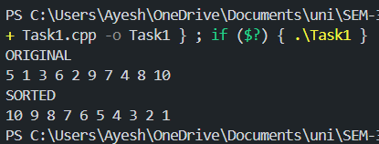

**TASK-2:**

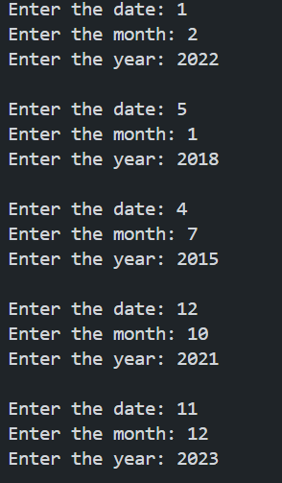

**TASK-3:**

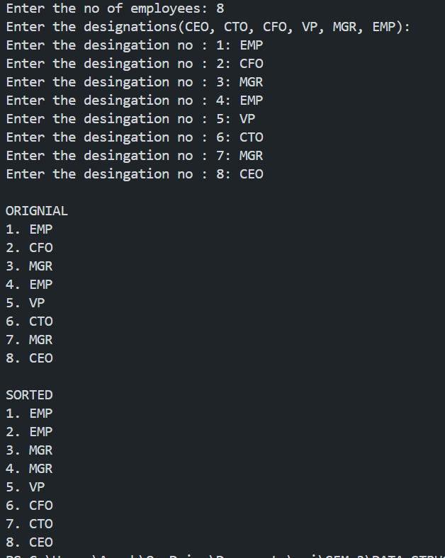

**Task-4**

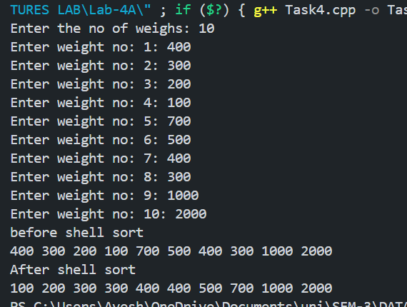

**Task-5**

